For Immediate Release

KELLI WELLI

NEW RELEASE: SUNSHINE IS MEDICINE (SINGLE)

PRODUCED by JOHNNY CLAY of ANTS ANTS ANTS

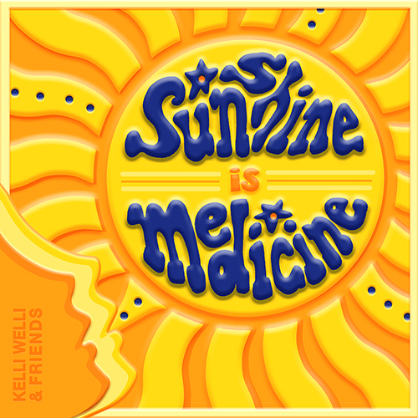

Song Details: Sunshine Is Medicine
Song release date: July 11, 2025
Label: 1st + 1st Media
For all ages, but especially for ages 0-14
Song run time: 02:35

Press download: https://www.kelliwellikids.com/press

PORTLAND, OR (June 20, 2025) – New Music Release! Kids independent—or “kindie”—creatives at it again with a new release about using your voice and opening up to let sun shine in when times get dark. Kelli Welli teams up again with PNW friend and neighbor, Johnny Clay, to produce the song, and then Suzi Shelton and Little Miss Ann, who make a wonderful team as Birds of a Feather agreed to add their voices. After that, Kelli’s 11-year-old twins, Ryan and Kira, and Johnny’s daughter Emma, came into the studio to add their radical kid energy to the song. This is the second song produced for Kelli by the multi-talented Johnny Clay of kindie band Ants Ants Ants and folk pop band The Dimes.

“We wanted to come together to bring a lot of energy to the message behind this song: It’s storytelling that changes hearts and minds more than anything… people sharing what they’ve been through and opening up, especially when it’s done with love and honesty.” says Kelli Welli. “My kids said most people will just think this is a song about going outside—and of course, getting outside and into the actual sunshine is wonderful medicine—but the point of this song is really to encourage people to tell their stories, to open up the windows and the doors that keep secrets and sadness locked inside and steal our power. We need to let it all out. We know what the saying means, but in these times, it’s feeling more important than ever to remember and do it.”

ABOUT KELLI WELLI: Kelli Welli (aka Kelli Caldwell) has been called “The Pixar of Children’s songwriters” for her award-winning work and commitment to keeping even the silliest of songs super smart, with full respect for kids’ brains. Recently named the Grand Prize Winner in the John Lennon Songwriting Contest and Top 3 in the International Songwriting Competition, Kelli draws upon her unique upbringing to create songs that often defy categorization. Kelli’s wide-ranging songwriting is clever, fun, often hilarious, sometimes reflective and deeply sweet. Always genuine. Kelli’s released four full albums in the last four years and can be heard on SiriusXM Kids Place Live. Her newest endeavors also include short film making, with inclusion in over 30 film festivals world-wide, including the Sonoma Film Festival, San Diego Comic Con, Children’s Film Festival of Seattle, and Portland’s one-of-a-kind gem, the Hollywood Theatre at PDX Airport. KELLIWELLI.COM
ABOUT JOHNNY CLAY: Leader of the folk pop band The Dimes, Johnny Clay has enjoyed a run of buzz fueled by his unique ability to craft catchy pop songs framed around fascinating historical themes and lyrics, as best demonstrated on the band’s 2009 release, “The King Can Drink the Harbour Dry.” In 2018, Clay formed the kindie band Ants Ants Ants with fellow singer/songwriters Dave Gulick and Nat Johnson from the indie rock band Derby. Ants Ants Ants has gone on to release 4 critically acclaimed albums and EPs and has become a staple of the Pacific Northwest summer festival circuit. JOHNNYCLAYMUSIC.COM
# # #

