For Immediate Release

New Music Releasing on NATIONAL DOG DAY
August 26, 2026

A DUO-SPECIES DUO-ALBUM RELEASE
One album for DOGS and another album for KIDS...
and the people who love them

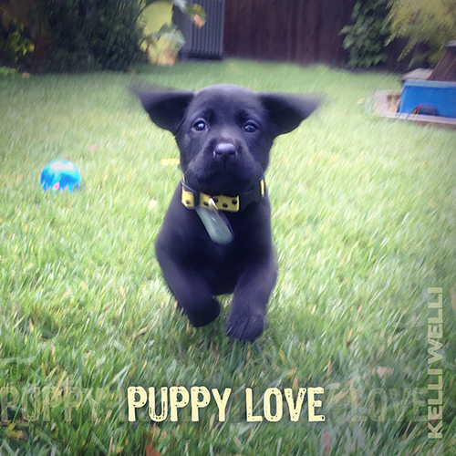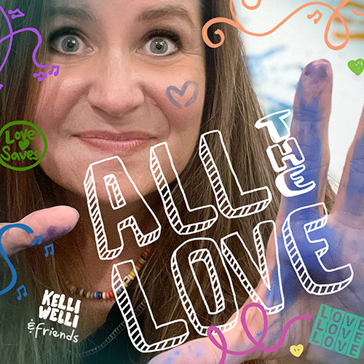

Album Details: PUPPY LOVE
Album release date: August 26, 2026
Label: 1st + 1st Media
For all ages
Album run time: 34 mins 23 secs
UPC: 885000118876
15 Tracks
Album Details: ALL THE LOVE
Album release date: August 26, 2026
Label: 1st + 1st Media
For all ages
Album run time: 36 mins 31 secs
UPC: 885000141584
15 Tracks

Press download: https://www.kelliwellikids.com/press

PORTLAND, OR (July 30, 2026) – You’ve heard of a bi-lingual music release, and not long ago, Kelli Welli put out a “bi-species release,” i.e. two versions of the same song: one for humans and one from a dog’s point of view. Well now comes the next evolutionary step, a so-called “duo-species, duo-album release” — one full, 15-track album for DOGS and the people who love them AND another 15-track album for KIDS and the people who love them — just in time for National Dog Day on August 26, 2026.
This newly-coined, sure-to-become-the-latest-trend-on-platforms-everywhere idea comes from the decidedly human, but dog-loving Kelli Welli. On a local level, she’s been named one of PDX Parent Magazine’s 2026 “Top 5 Reader’s Picks.” And nationally, she’s recently been recognized as a top songwriter by American Songwriter Magazine and the John Lennon Songwriting Contest, as well as awarded Best Children’s Album by the Josie Music Awards hosted at the Grand Ole Opry in Nashville.

PUPPY LOVE was inspired by and features the talents of real doggies. It’s filled with a lot of fun, songs told from the dog’s perspective, and light shone on the quirky moments that can only come with these most wonderful of creatures. It includes the touching and poignant song, “Rescue” that was recognized in Americana by the prestigious International Songwriting Competition. A portion of proceeds from the album will be donated to the American Humane Society.

ALL THE LOVE presents music to fill all the seasons with a whole lotta love, featuring a host of Kelli’s real human friends and family, including Grammy® nominated and massively talented artists, producers, engineers, and musicians, and includes the title song produced by Portland’s one-and-only Mo Phillips that recently brought Kelli the title of Best Children’s Artist at the Unsigned Only Music Awards.

MORE ABOUT THE 1st ALBUM: PUPPY LOVE

In addition to being mom to two human kids — twins Ryan and Kira, age 13, a boy and a girl — Kelli has a wonderful fur-baby, Piper Peach (Black Labrador Retriever), who is pictured as a tiny bounding pup on the PUPPY LOVE album cover. Piper Peach is a constant source of joy and love for Kelli and her family, so it’s no surprise she would inspire songs.

Piper Peach apparently wrote a song called “Dirty Socks,” now considered a classic to those who’ve heard and can relate. She contributed to many ideas and vocalization throughout the album, along with her best canine friends, Loki Newman (Golden Retriever, Border Collie mix) and Mia Swanson (Australian Cattle Dog/German Shepherd, Siberian Husky mix). Loki performed his signature trill to the “mouth horn” section of “Road Trip (Dog Version)” — a nod to Woodie Guthrie’s "Riding in My Car.”

According to Kelli: “I’ve had a dream for a while to make an album for DOGS and the people who love them. I live in a part of the US where dogs are virtually everywhere, a huge part of the culture, as they are of course loved and cherished family members.”

And Kelli’s wonderfully talented friends really showed up to help make this come true, including the Newman Family (including Devon, Mark, Aidric, and Jack Newman, humans belonging to the dog, Loki, mentioned above), Blaine Heinonen, Jennifer Smieja, Tom Walker, Timothy James Uecker, guest artist Headkrack, Sarah McCarthy, and the album’s producer Bryan Daste. “I was thrilled to make these songs with friends who also have fur-babies or love them — and are surprisingly great at mustering up their own canine traits when called.” Kelli says.

“I also wanted to make an album for pup parents who may be kind of tired of being asked if they have (human) kids. One of the best people in my life was my aunt who had no human kids, but was mom to many golden retrievers. I had kids later in life, so I’ve had the question many times that comes with an undertone something must be wrong with you if you aren’t married with children. Enough of that. For many, their family feels plenty complete without any dependents — or with their fur-babies. Not something to have to justify, but to celebrate.”

MORE ABOUT THE 2nd ALBUM: ALL THE LOVE

This 15-track album includes brand new music about friendship and nature, as well as songs to celebrate ALL THE LOVE we can share with the (human) kiddos in our lives throughout the year. Whether out on an adventure, as in “River Run: Grand Canyon” that Kelli wrote while on an 8-day raft trip in that canyon with her kids and family, or marveling at the birds outside the kitchen window where her kids have grown, so many of the songs included mark cherished moments and memories.

The album is made all the more special by all the incredible friends who showed up to lend their talents and great heart. Guest children’s artists, Grammy® nominated Nanny Nikki, Grammy® nominated Wendy & DB, Tara Trudel, Shawny, and The Dapper Dudes sing a chorus of friendship in "Want to Be Your Friend,” a song to show kiddos how to just say it out loud: “I want to be your friend!” With the lyrics, “I want to be your friend, we’ll ride to the rainbow’s end…” Kelli reflects on the treasure of a long-lasting friendship, with a nod to the traditional campfire song: “Make new friends, but keep the old… one is silver and the other is gold.”

Then even more friends showed up to bring ALL THE LOVE to this album, like Red Yarn, Suzi Shelton & Little Miss Ann who teamed up to form Birds of a Feather. Ben Tarne of Portland’s own Music Quest and Paul DeHaan brought big dad energy to the “Pumpkin Run” song, perfect for harvest festival fun runs. And Timothy James Uecker’s instrumentals shine in various tracks, including “Twinkle Instruminkle” a variation on the classic song.

And of course the most special humans who brought their energy and light to fill this album with ALL THE LOVE are Kelli's wonderful kids, Ryan and Kira Segelken, who inspired so many of the songs. They contributed vocals, voiceover, claps, and more, including an original song written and performed by Kira when she was 8 years old. Other kid friends joined too, including a group of over fifty 4th graders from their elementary school, who brainstormed ideas and sang along with “The Responsibility Song” as part of a school project.

ABOUT THE PRODUCERS:
BOTH albums were primarily produced by Kelli’s stellar producer, engineer, and multi-instrumentalist Bryan Daste, who toured with Grammy® nominee Courtney Marie Andrews and played on Laura Sullivan’s Grammy® nominated album. But ALL THE LOVE also features the talents of guest producers Johnny Clay of acclaimed The Dimes and children’s band Ants Ants Ants on songs, “Sunshine is Medicine” and “Sweet Dreams,” mastered by Grammy® winner Will Hensley; Portland rockstar, Mo Phillips for “All the Love;” and Andrew Oedel of Ghost Hit Recording out of West Springfield, MA, on “Feeding the Birds,” who’s worked many Grammy® winners and nominees, including kindie favorite, Alastair Moock.

ABOUT THE DOGS:
Piper Peach (Black Labrador Retriever) loves balls, toys that squeak, and dirty socks. She especially loves trying to catch or bite water from a hose and swimming or basking in water anywhere. She loves her friends, but also prefers being the center of attention. Human family: Kelli Welli & family.

Loki (Golden Retriever/Border Collie mix) is one of the sweetest people... he greets with the truest joy. He enjoys cornering chipmunks in the wood pile and keeping dedicated watch for squirrels, as well as his weekly adventure day out. He's known throughout the Pacific Northwest music community for the skill in his trill. Human family: The Newman Family.

Mia (Australian Cattle Dog/German Shepherd/Siberian Husky mix) is smart as a whip and a bundle of energy. She enjoys micro-managing, bird watching, catching balls, hide and seek and a long walk in the neighborhood. She never forgets anything and has supersonic hearing. She also loves snap peas. Human family: The Swanson Family.

ABOUT SONGWRITER KELLI WELLI: Kelli Welli (aka Kelli Caldwell) has been called “The Pixar of Children’s songwriters” for her award-winning work and commitment to keeping even the silliest of songs super smart, with full respect for kids’ brains. Recently named Unsigned Only Best Children’s Artist, Grand Prize Winner in the John Lennon Songwriting Contest, Best Album in the Josie Music Awards, and Top 2 in the International Songwriting Competition, Kelli draws upon her unique upbringing to create songs that often defy categorization. Kelli releases her 5th and 6th albums for kids in 2026 and her songs can be heard on children’s radio, including SiriusXM. Kelli’s short films for kids have been included in over 50 film festivals world-wide, including San Diego Comic Con, the Sonoma Film Festival, Portland Film Festival, Brooklyn Academy of Music BAMkids Festival, Children’s Film Festival of Seattle, and more. KELLIWELLI.COM

TRACK LIST FOR PUPPY LOVE
1. Dog Party
2. Soggy Doggy Toy
3. Rescue
4. Road Trip (Dog Version feat Loki & The Newman Family)
5. Unconditional Love
6. Dirty Socks
7. Then You Will Run Free (Barer Bones Version)
8. Whatcha Gonna Do When Your Doggie’s with You (by Kira Segelken)
9. Sweet Dreams, My Doggie
10. Song About My Dog’s Flatulence
11. Dogs Doin’ Dishes
12. Dogs Dig Reggae: Ooh La La (instrumentalala)
13. Dognado
14. Rainbox – A Dog’s Take
15. Soggy Doggy Toy (Reprise by Headkrack)

TRACK LIST FOR ALL THE LOVE
1. Want to Be Your Friend (feat Nanny Nikki, Wendy & DB, Tara Trudel, Shawny, The Dapper Dudes)
2. All the Love (feat Mo Phillips)
3. My Darling Daffodil (feat Red Yarn)
4. Sunshine is Medicine (feat Birds of a Feather, Ryan & Kira Segelken)
5. River Run: Grand Canyon
6. Feeding the Birds
7. Feelings Take Practice
8. Road Trip (Human Version feat The Newman Family)
9. Frickle Instrumickle (instrumental)
10. The Responsibility Song (feat West TV Sunglass Brigade)
11. Pumpkin Run (feat Paul DeHaan & Ben Tarne)
12. Spider on Your Eyelid (feat Bryan Daste & Sarah McCarthy)
13. Sweet Dreams
14. Twinkle Instruminkle (instrumental)
15. I Believe in You
###

For more information about Kelli Welli or to schedule an interview, please contact 503-476-5300 or email kelliwellikids@gmail.com. | Visit Kelli Welli’s website at www.kelliwelli.com

