For Immediate Release

KELLI WELLI

NEW RELEASE: FEELINGS TAKE PRACTICE (SINGLE)

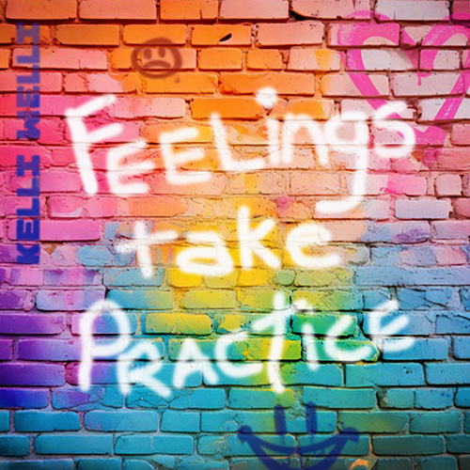

Song Details: Feelings Take Practice
Song release date: August 22, 2025
Label: 1st + 1st Media
For all ages, but especially for ages 0-14
Song run time: 01:35

Press download: https://www.kelliwellikids.com/press

PORTLAND, OR (August 22, 2025) – New Music Single Release! Kelli Welli’s latest single release is a short, gentle, a cappella performance of a song about feelings. Understanding big feelings, or even small feelings, is a process that we start in our infancy, but it’s amazing how long it can sometimes take in our lives to be able to hear and interpret what our bodies are telling us is going on inside. And the message in this song is: That’s ok. Feelings take practice.

So let’s talk about our feelings and let’s talk about the signals that might help us understand our feelings. And let’s not forget in this busy, distraction-driven world — it’s often in the quietest places that we hear the most important things we need to know, including about ourselves. This song is for kids, adults, educators, anyone trying to help kids understand and learn how to regulate their feelings and bodies, as well as a reminder to anyone going through confusing times themselves.

ABOUT KELLI WELLI: Kelli Welli (aka Kelli Caldwell) has been called “The Pixar of Children’s songwriters” for her award-winning work and commitment to keeping even the silliest of songs super smart, with full respect for kids’ brains. Recently named the Grand Prize Winner in the John Lennon Songwriting Contest and Top 3 in the International Songwriting Competition, Kelli draws upon her unique upbringing to create songs that often defy categorization. Kelli’s wide-ranging songwriting is clever, fun, often hilarious, sometimes reflective and deeply sweet. Always genuine. Kelli’s released four full albums in the last four years and can be heard on SiriusXM Kids Place Live. Her newest endeavors also include short film making, with inclusion in over 30 film festivals world-wide, including the Sonoma Film Festival, San Diego Comic Con, Children’s Film Festival of Seattle, and Portland’s one-of-a-kind gem, the Hollywood Theatre at PDX Airport. KELLIWELLI.COM
# # #

